**How to Configure Replication:**

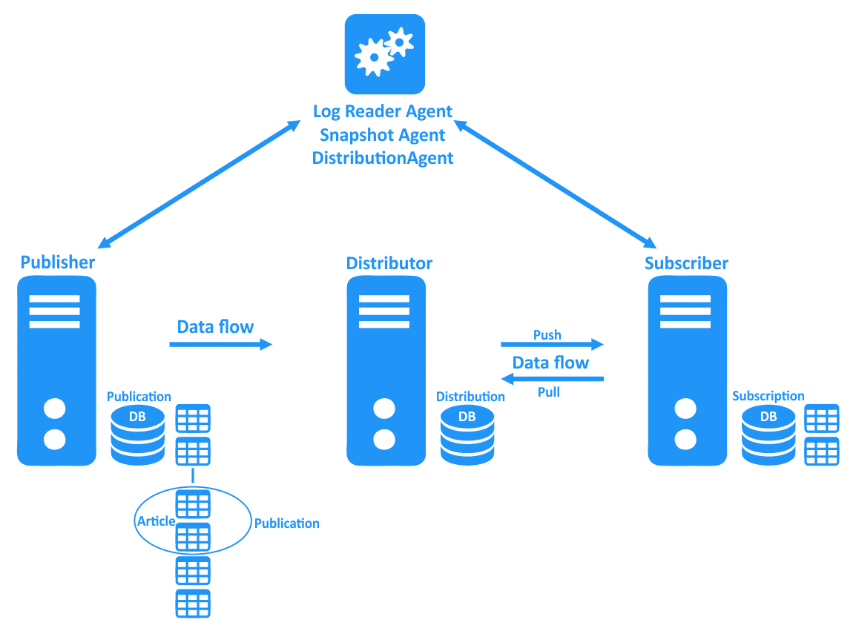

**Step 1: Configuring the SQL Server Distributor**

* To configure the SQL Replication Distributor, follow the steps given below:
* Open SSMS and establish a connection to your SQL Server instance.
* Right-click on the “Replication” folder on the Object Explorer and select “Configure Distribution”.

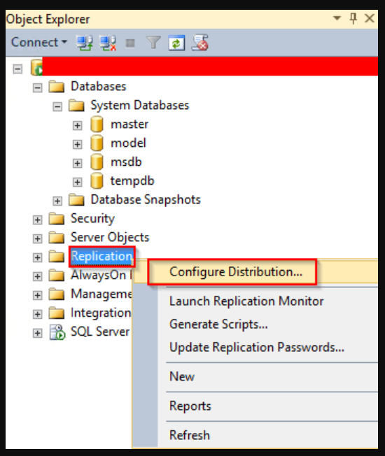

* The “Distribution Configuration Wizard” will popup. The wizard shows the general details about configuring the Distributor. Just click on the “Next” button.

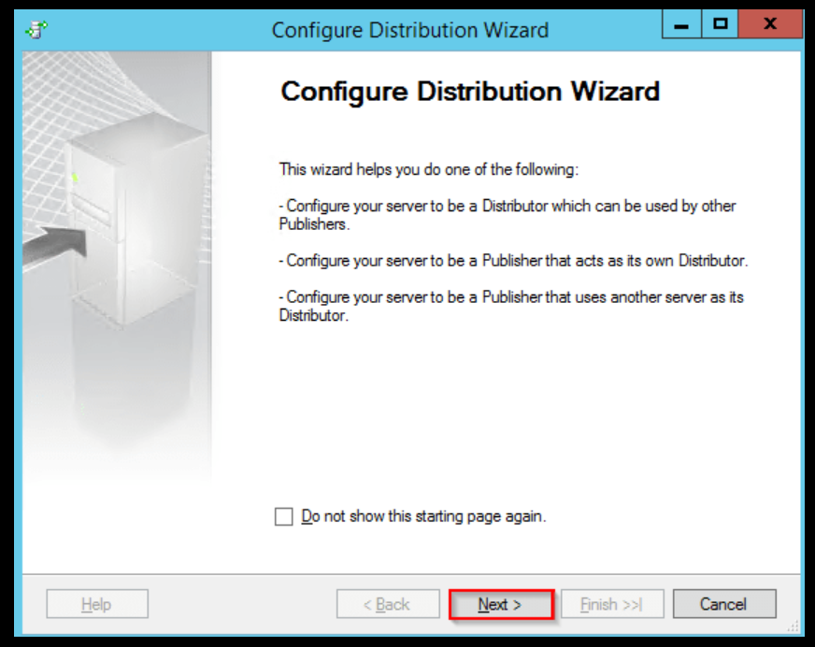

* On the “Distributor” page, you can set the current instance as the Distributor or choose another instance that has already been configured as a Distributor.
* Click on the “Next” button.

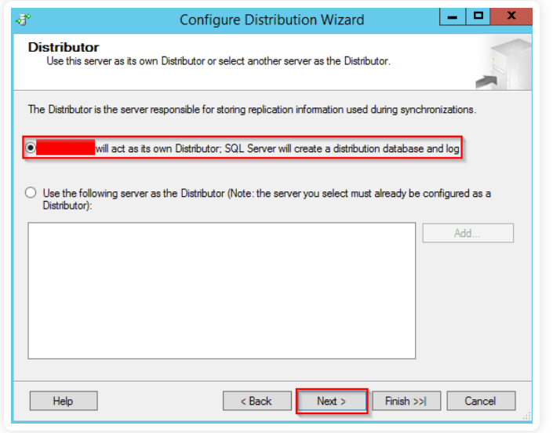

* In the next window, type the path to the SQL replication snapshot folder, or go with the default path. In my case, I will use the default path.
* This folder is used for initial data synchronization of Transactional Replication, so ensure that it has enough size to hold all the replicated data.
* Click on the “Next” button.

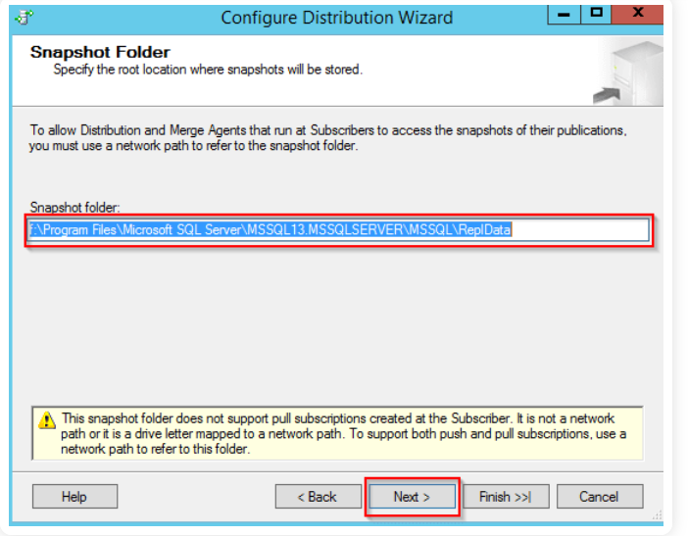

* You can now configure the replication distribution database. Give the distribution database a name and specify the location of the data and log files.
* Click on the “Next” button.
* You will be taken to the “Publishers” page. Specify the Publishers that will access the Distributor, and then click on the “Next” button.
* In “Wizard Action”, you can choose to run immediately or create a script to be executed later. Click on “Next”.
* In the next window, review the settings and configuration options. If they are okay, click on the “Finish” button to enable the Distributor.
* You will then be taken to the “Success” window, meaning that the configuration was successful.
* Now that the Distributor is ready, let’s go ahead and configure the Publisher.

### Step 2: Configuring the SQL Server Publisher:

* Expand the “Replication” folder from the “Object Explorer”. Right-click on “Local Publications” and choose “New Publication”.

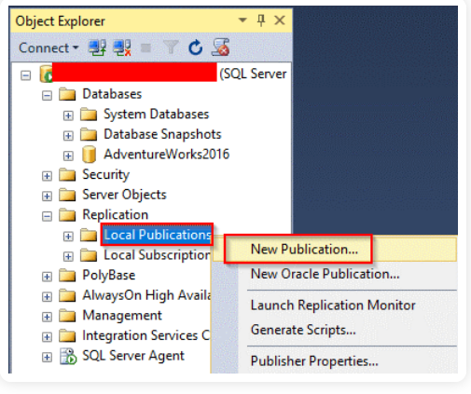

* A new window will appear giving you the general details about creating a new publication. Click on “Next”.

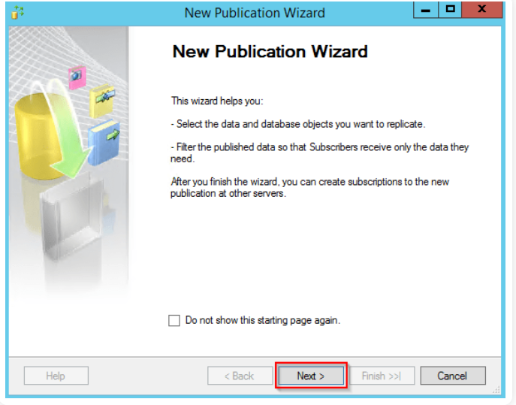

* The “Publication Database” window will appear. Choose **AdventureWorks2016 database**, and then click on “Next”.
* The “Publication Type” window will appear. Choose [“Transactional Publication”](https://docs.microsoft.com/en-us/sql/relational-databases/replication/transactional/transactional-replication?view=sql-server-ver15) then click on “Next”.

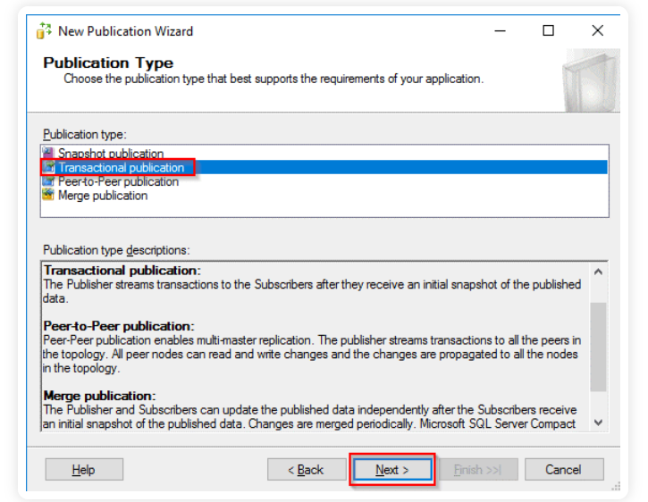

* You will be taken to the “Articles” page. Select all the articles that you need to be included in the publication and click on “Next”.
* You will be taken to the “Filter Table Rows” page. Here, you should specify the filters to be applied to your articles.
* Just go with the default values. Click on “Next”.

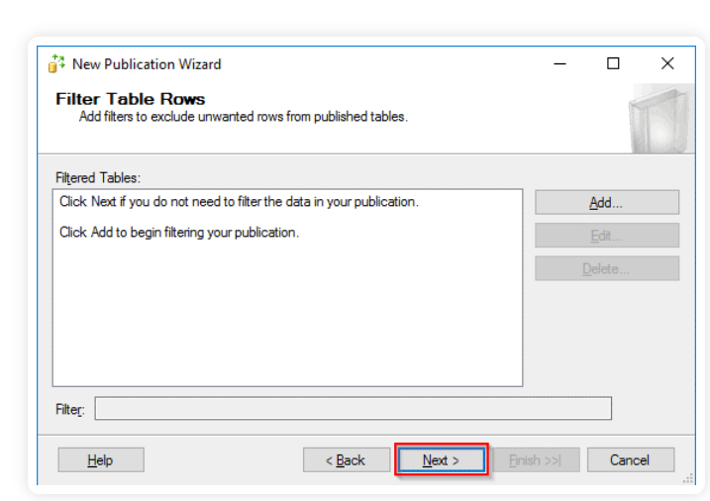

* In the next window, you should specify when the Snapshot Agent will start. You can run it immediately or schedule it to be run later.
* Choose the first option, which is to create a snapshot immediately.
* Click on “Next”.

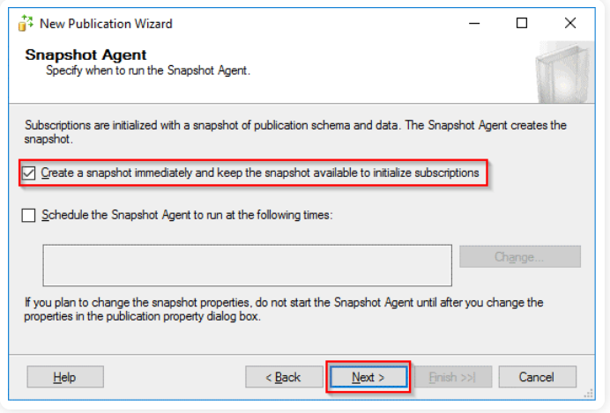

* On the next page, specify the account to be used to run the [Snapshot Agent](https://docs.microsoft.com/en-us/sql/relational-databases/replication/agents/replication-snapshot-agent?view=sql-server-ver15) and click on “OK”.
* Choose the first option to create the publication immediately. Click on “Next”.

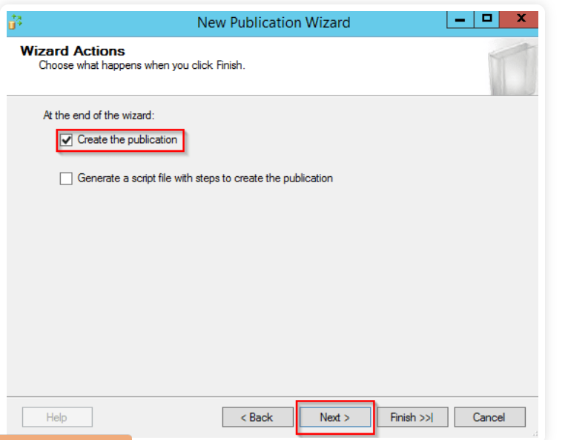

* Type in the name for the publication and click on “Finish”. I have given it the name, AdvWorks_Pub.
* In the next window, you should see the success message.
* You can then check under “Local Publications” to confirm whether the publication has been created.

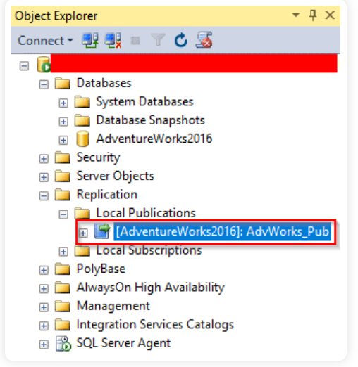

### Step 3: Configuring the SQL Server Subscriber:

* This is the final step of setting up SQL Server Replication.  To create the subscription, follow the steps given below:
* Expand the “Replication” folder from “Object Explorer”, right-click on “Local Subscriptions”, and then choose “New Subscriptions”.

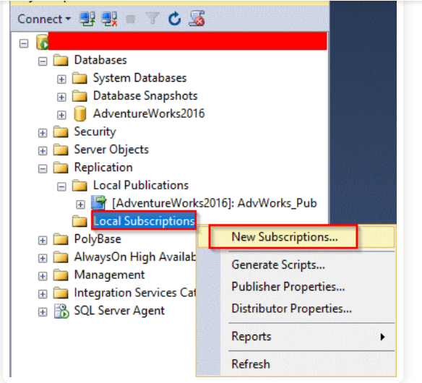

* The next window will show the general details about creating subscriptions. Click on “Next”.

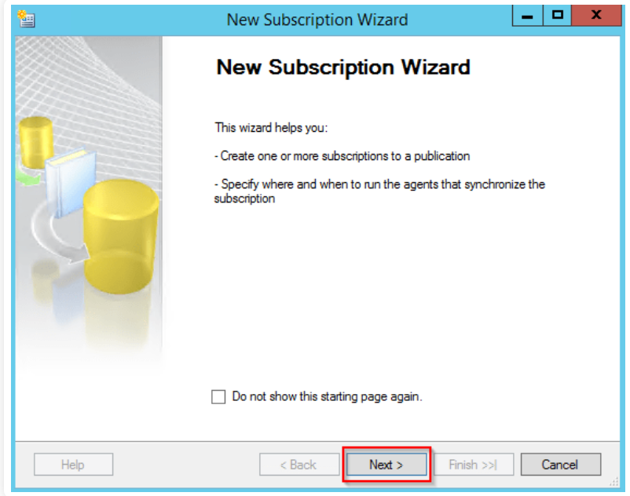

* In the next window, select the publication and then click on “Next”.
* The “Distribution Agent Location” page will be opened. Select “Run all agents at the Distributor”, and then click on “Next”.

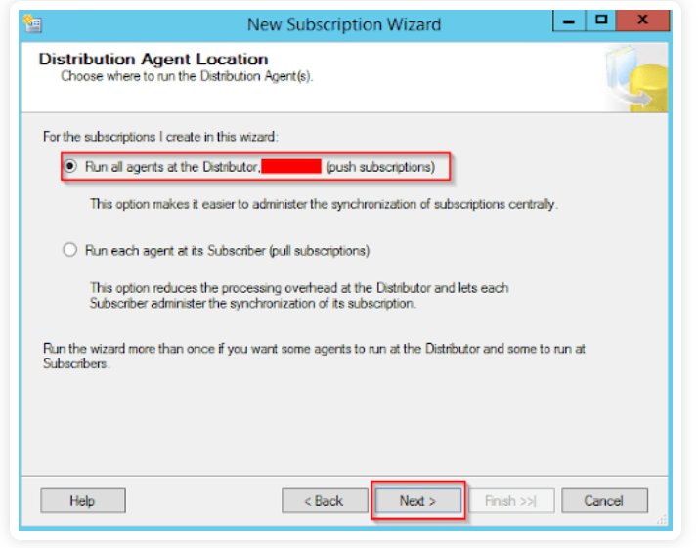

* The “Subscribers” window will open. Select “Add Subscriber”, and then select “Add SQL Server Subscriber” from the provided drop-down.

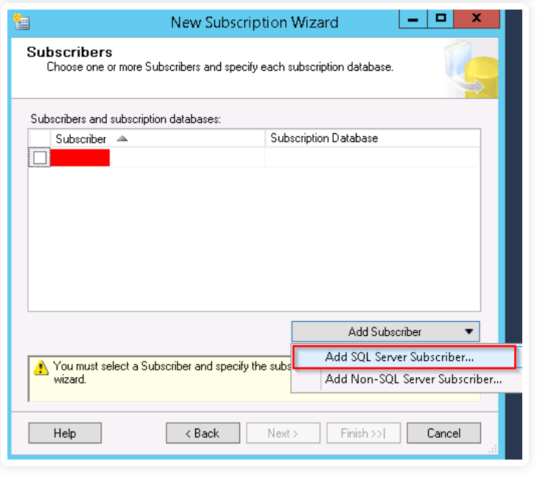

* The “Connect to Server” dialogue box will be opened. Enter the name of the Subscriber instance and choose “Connect”.
* After adding the SQL Subscriber instance, select the dropdown next to your Subscriber instance. Select “New Database”, type the name of the database, and then click on “OK”. Since it’s a replica database, I have given it the name AdventureWorks2016.

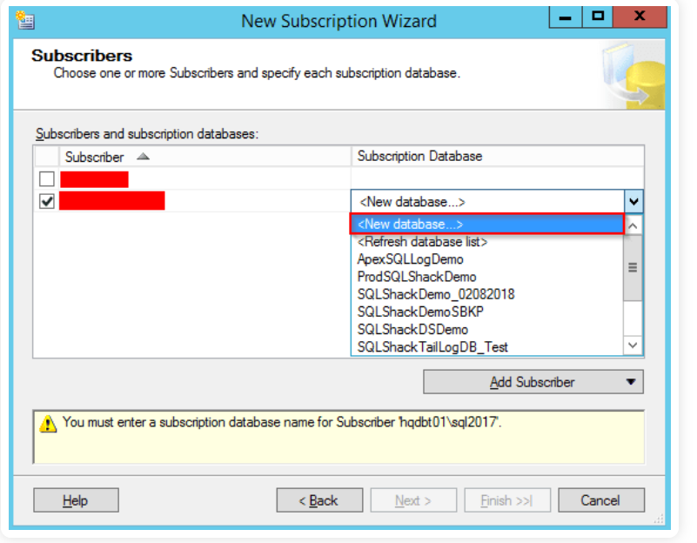

* The subscription database will be created and then registered to the Subscriber. Ensure that the account has the db_owner permission on the new database.
* The “Distribution Agent Security” page will be opened. Click on the ellipsis (…) button. Type in the details of the process account then click on “OK”.

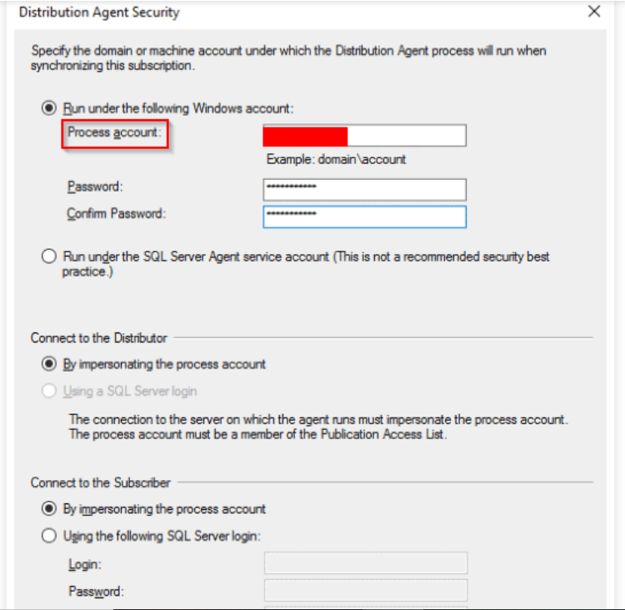

* Click on the “Finish” and accept the default values on the remaining pages.
* On the**“**Creating Subscription(s)…” page, you will know whether the process was successful or not. Click on “Close”.

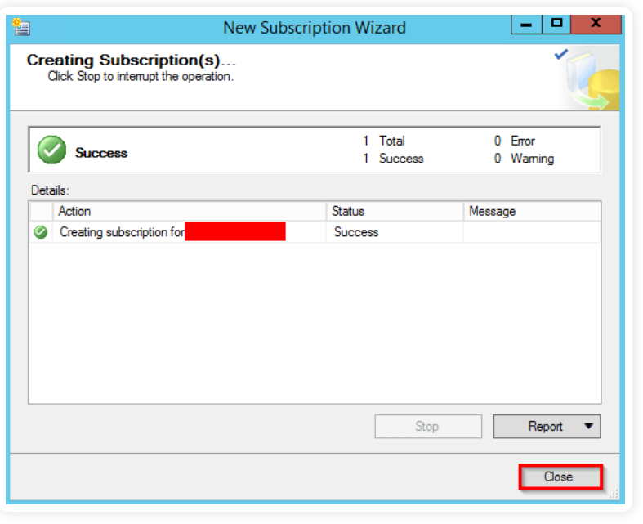

* Establish a connection to the Publisher in the SQL Server Management Studio. Right-click on the “Replication” folder from “Object Explorer”, then select “Launch Replication Monitor” so as to check the status of the Transactional Replication setup that you have just created.

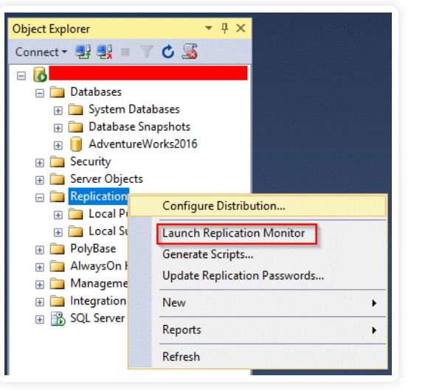

**You should now be able to see data being propagated between the servers when you insert, update, or delete data from the articles that you included in the publication.**